

19P0012 AITZAZ TAHIR CH

DATA BASE LAB 11 SIR MUHAMMAD USMAN



**Exercises**

**Create a database named your rollno_section (i.e. 19P0084_4A).**

use 19P0012_4A

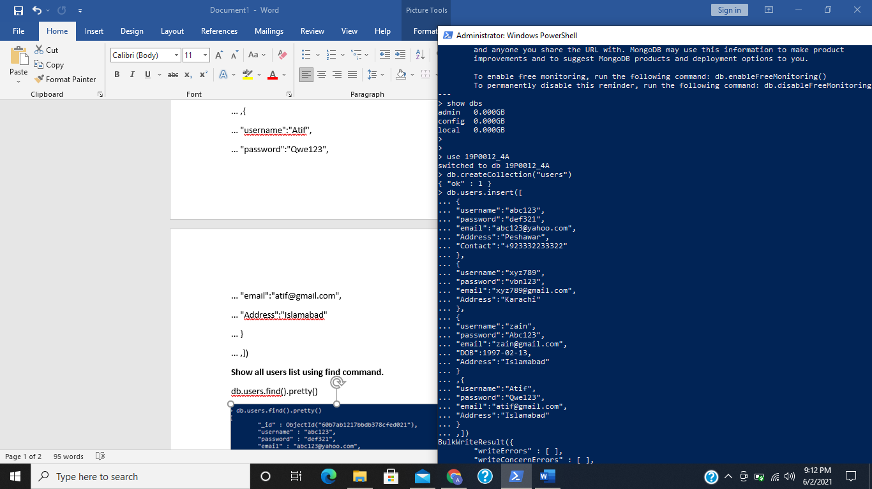

**Create a collection named users.**

db.createCollection("users")



**Insert the following record in the user’s collection.**

db.users.insert([

... {

... "username":"abc123",

... "password":"def321",

... "email":"abc123@yahoo.com",

... "Address":"Peshawar",

... "Contact":"+923332233322"

... },

... {

... "username":"xyz789",

... "password":"vbn123",

... "email":"xyz789@gmail.com",

... "Address":"Karachi"

... },

... {

... "username":"zain",

... "password":"Abc123",

... "email":"zain@gmail.com",

... "DOB":1997-02-13,

... "Address":"Islamabad"

... }

... ,{

... "username":"Atif",

... "password":"Qwe123",

... "email":"atif@gmail.com",

... "Address":"Islamabad"

... }

... ,])



**Show all users list using find command.**

db.users.find().pretty()

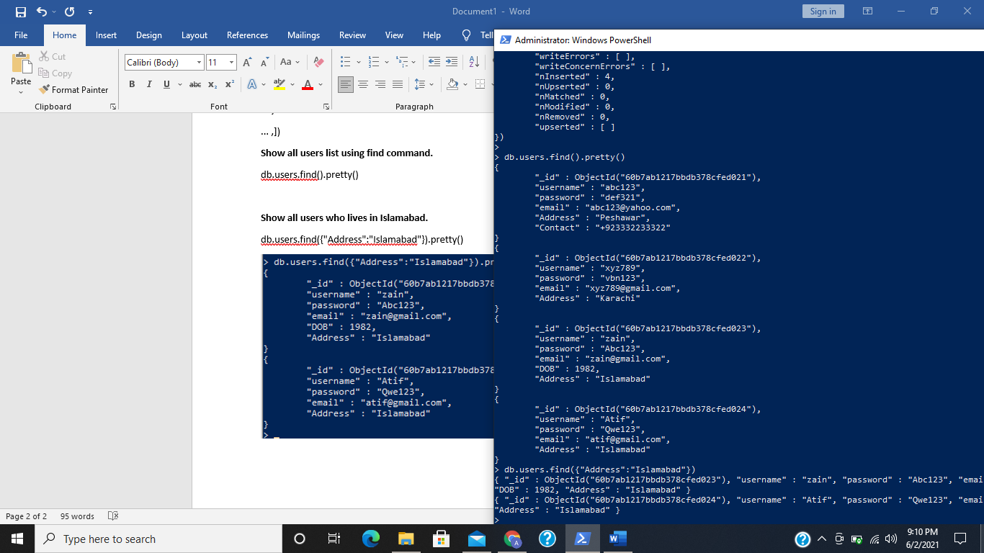

**Show all users who lives in Islamabad.**

db.users.find({"Address":"Islamabad"}).pretty()

